APD TRAIN Florida
Frequently Asked Questions (FAQs)
The list of FAQ topics below is expandable and collapsible. To view the answers to the questions, click the arrow point to the left of the heading/question. Click the pointer again to collapse the section.

TRAIN Florida Navigation

How do I find the TRAIN Florida login page?
- Copy and paste this address to your browser’s address bar: https://fl.train.org
- Links to TRAIN Florida can be found on the APD Training Portal.

How do I navigate TRAIN Florida?
A number of resources are available on the APD Training Portal and in TRAIN Florida’s Resources. The APD Learning Management System support team has created the How to Navigate Train Florida guide.

Learner Accounts

How do I get a TRAIN Florida account?
Registering for a TRAIN Florida learner account depends on how you will be using the account. First, review the account types listed below to see which applies to you. Instructions for registering for an account are available on the APD Training Portal. If you are not sure whether you should create your own TRAIN Florida account, please check with your agency to see if they have created one for you, or you can contact the APD LMS Support Team.
- APD Employees – Employees who work directly for APD
- APD Independent Contractors - Providers who are not on an agency/organization’s staff.
- Providers Pending APD Approval - Providers who have submitted a request to their regional offices and are waiting for approval from APD.
- Agency Staff Employees - Employees who are currently employed by a provider agency/organization. Your agency uploads your information to APD LMS Support for registration.
- Prospective Employees - Individuals who are seeking employment with an organization, but have not yet been hired. Agency does not send in a request for registration on TRAIN Florida.
- Florida General/APD Customers - Individuals or organizations who are not in the APD Provider network.
Important: Do not create more than one TRAIN Florida account. Creating multiple accounts will cause the system to lock you out.
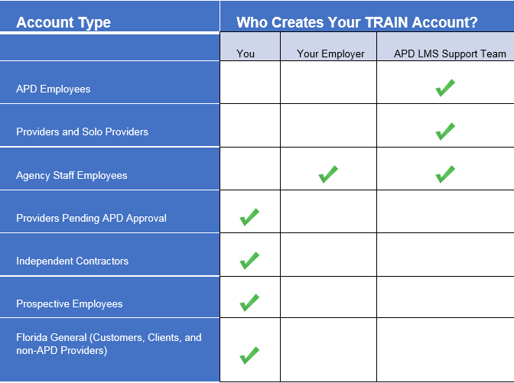

I forgot my username and password. What do I do?
On the TRAIN Florida Login page is the Login/Password Help Tutorial. You can learn how to retrieve your login and password information by clicking the Login/Password Help Tutorial link. If you cannot retrieve your login information, please contact the TRAIN Florida APD site administrator by email at apd.lmssupport@apdcares.org
Important: Do not create another account.

I receive an “Invalid Account” message when I try to log in. What do I do?
If you receive an Invalid Account message when you try to log in, do the following:
- Click the back button and return to the TRAIN Florida login page.
- Try your password again.
- If you receive another Invalid Account message, then click the Forgot your password? link.

I work for multiple providers: How do I manage my TRAIN Florida account?
TRAIN Florida learners can only have one account. If you work for or are going to work for multiple agency providers, your account can be updated with two agency providers’ information. All TRAIN Florida courses you complete in your account will be available/reported to both agencies. For example, if you completed the APD Required trainings for Agency “A”, Agency “B” will have access to your completed trainings.

If you work for or are going to work for multiple agency providers, please follow the steps below:
- Please let the Provider know that you already have a TRAIN Florida Account
- Please do not create another TRAIN Florida Learner account, this will lock both accounts.
- You can email or print your TRAIN Florida Transcript and Certificate for the Provider.
- Please do not change the information in your TRAIIN Florida “My Account” page. This information is used for the Provider Agency TRAIN Florida reports.
- If you work for three or more providers, you can email or print your TRAIN Florida Transcript and Certificate for the Provider.

Where do I go to find answers to my questions?
Answers to commonly asked questions can be found here in the FAQs and in the following locations:
- Go to the APD Training Portal TRAIN Florida Help link.
- You can post your question on the TRAIN Florida APD Discussion Board. All APD Discussion Board threads are monitored and triaged daily by the TRAIN Florida APD site administrators.
- You can contact the TRAIN Florida APD site administrator by email at apd.lmssupport@apdcares.org

I am a new APD employee or provider. How do I get started in TRAIN Florida?
Your account was created for you and you should have received an email from Fl_Admin@train.org with your login information and instructions to get started in TRAIN Florida.
If you did not get this email, please contact the TRAIN Florida APD site administrator by email at apd.lmssupport@apdcares.org.
Please Do Not Create a TRAIN Florida Account.

I am an APD customer/General Public. Where do I find the APD training information?
APD customers and the general public can create their own TRAIN Florida accounts. Information for creating an account is available on the APD Training Portal.

I am an APD provider. Where do I find the APD training information?
The APD Training Portal has the Training Tools, Information, and Resources to help manage TRAIN Florida and APD core and essential trainings. These resources are designed specifically for TRAIN Florida APD learners, and are continually updated to help you manage the TRAIN Florida system and provide help for all APD learners.

Providers/Managers

I want to check to see if members of my staff have existing accounts on TRAIN Florida. What is the process for doing this?
- Check with the employee before contacting APD LMS Support. If the employee has an existing account, there is no need to have them create another account.
- If the employee(s) does not have an existing TRAIN Florida account, complete the APD Staff Upload Spreadsheet (there is a specific Excel file template that is used) that is available on the APD Training Portal on the Managers page. Follow the instructions for completing the spreadsheet and then send the spreadsheet as an attachment to an email with Subject: Staff Upload Request. Be sure to include your name, your agency’s name and provider ID, email address, and phone in the signature line of the email.

My employees work for multiple providers: What is the process for managing their TRAIN Florida accounts?
- If you have a prospective employee, please ask them if they have a TRAIN Florida account. If they do, have them email or print their TRAIN Florida Transcript.
- If the prospective employee is not sure whether they have an account, please send an email to the APD TRAIN Florida Support Team @ apd.lmssupport@apdcares.org, requesting a search for the Learner Account.
Please include the following information in the email request:
  - Your Agency Name
  - Provider ID number
  - Agency Contact Name and email address
  - The prospective employee’s full name and email address
- Request a TRAIN Florida Provider Staff Report. If staff works for at least two providers, the TRAIN Florida Provider Staff Report should reflect this information in the Bureau/Section and Address 2 section of the report. Two separate Provider ID’s would be reflected in these fields.
- If the employee is not on the report, please do not submit a TRAIN Florida Upload spreadsheet, instead, let us know and we will update the account, or send you the employee’s TRAIN Florida transcript. Note: If the employee self-created their account, we must update the account information; this will delay sending the staff report back to you.

APD and Non-APD Courses in TRAIN Florida

How do I find the APD courses?
The Keyword or Course ID search bar is located on the upper-right side of the TRAIN Florida home page above the Dashboard. Enter a keyword, such as part of a course title, or the course ID and search the TRAIN database. Click here for instructions on how to locate APD courses.
Tip for APD learners! Enter APD into the Keyword or Course ID search bar and click the Search magnifying glass icon, TRAIN Florida will direct you to the Course Search page. The page will display all courses, discussions, and resources related to APD.

How do I find the course assessment (test) and evaluation?
The TRAIN Florida administrators have designed two short videos (less than 2 minutes long) that show you how to locate and complete a course assessment (test) and evaluation. The links to the videos are located directly below the Dashboard.
Course Completion Assessment and Evaluation - Blended Learning Series
Course Completion Assessment and Evaluation - Self-Pace
If you have any problems with locating and completing the course assessment and evaluation, please contact the TRAIN Florida APD site administrator by email: apd.lmssupport@apdcares.org

Where is my TRAIN Florida transcript?
Instructions are available to help you locate and manage your TRAIN Florida transcript.
Follow the steps below to get the instructions:
- Click the TRAIN Florida User Tools link on the TRAIN Florida Login page. The link will take you to the Learners Questions and Answers.
- Find the TRAIN Florida Course Management section, locate, and click on How to Manage my TRAIN Florida Transcript.
If you need additional help, please contact the TRAIN Florida APD site administrator by email at apd.lmssupport@apdcares.org.

How do I get non-APD courses on my transcript?
Instructions are available to help you get your non-APD courses on your transcript.
Follow the steps below to get the instructions:
- On the TRAIN Florida Login page, click the TRAIN Florida User Tools link. The link will take you to the Learners Questions and Answers.
- Find the TRAIN Florida Course Management section, locate, and click on How to manage NON-TRAIN courses.
If you need additional help, please contact the TRAIN Florida APD site administrator by email at apd.lmssupport@apdcares.org.

I completed a course, but it’s not on my transcript. What do I do?
A course is not completed until the learner completes the course assessment and evaluation. This is done through the Course Management page.
Once you have completed watching a presentation video, navigating back to the Course Management page can be a little tricky.
The TRAIN Florida administrators have designed two short videos (less than 2 minutes long) that show you how to locate and complete a course assessment (test) and evaluation. The links to the videos are located directly below the Dashboard.
- Course Completion Assessment and Evaluation - Blended Learning Series
- Course Completion Assessment and Evaluation - Self-Pace

If you have any problems with locating and completing the course assessment and evaluation, please contact the TRAIN Florida APD site administrator by sending an email to apd.lmssupport@apdcares.org.

Courses

Why will the course not launch for me?
Do not withdraw from a course after you register. If you are having difficulties with the following:

- launching a course
- managing a course
- locating a course assessment
- locating the course evaluation

Review the course instructions that accompany your registration email. If you cannot locate the registration email with the instructions, access the course instructions from the TRAIN Florida resource library. The steps for doing this are shown below.

- On the TRAIN Florida site, click the Resources link.
- On the left menu, click APD TRAIN Florida.
- Click APD Courses.
- Click the course name.
- Under Resource Name, click the course instructions link (shown as Click Here!).

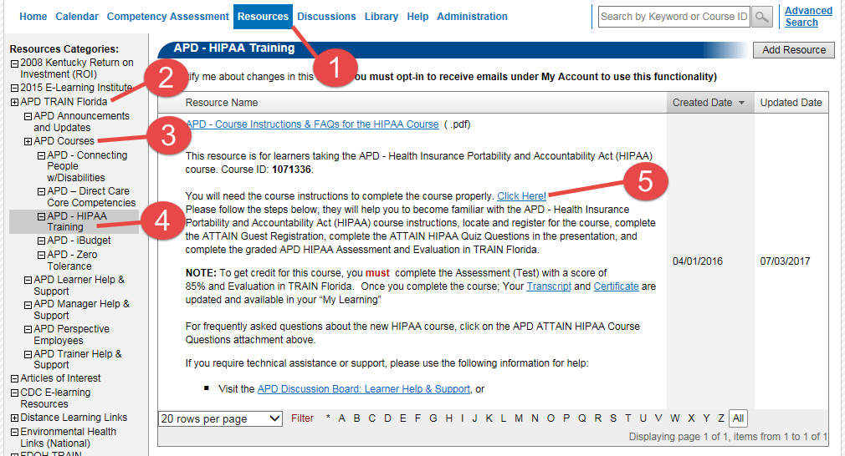

- If you are taking a course in a blended learning series (i.e., multiple modules) - you must complete each module in sequence and click the completed button when you are done. Review the steps provided in the course instructions that are sent to you in an email when you register for a course.
- If you are accessing the HIPAA course presentation and the ATTAIN website - the presentation will not launch in Chrome, on Mac products, or on mobile devices. You must be on a laptop or desktop that uses Internet Explorer. Additionally, you should turn off your system’s pop-up blockers. A list of these FAQs and troubleshooting options are available on ATTAIN’s HIPAA training page.
If you continue to have problems with a course, or if you have questions about completing a course, please send an email to the APD TRAIN Florida Support Team at apd.lmssupport@apdcares.org with the following:
Subject Line: Need help with a course.

APD-HIPAA Course 1071336: What happens if I fail the post-assessment in TRAIN Florida?
If you do not score a minimum of 85% on the post-assessment you will not receive your certificate. You must retake the course. Instructions for taking the APD-HIPAA course (ID 1071336) can be found on the APD Training Portal’s Courses page.

Help Resources

What resources should I check if I need help?
- The first place you should check for information is the APD Training Portal and the Learner Help and Support web page. There, you will find information for training requirements and the materials and tools needed for completing your required courses. Information specific to APD courses on TRAIN Florida as well as navigation and course instructions are available on this site as well.
- In TRAIN Florida, you will find information located under Resources and on the Discussion Board. To quickly locate all APD-related information, type APD into the Search bar and press ENTER.
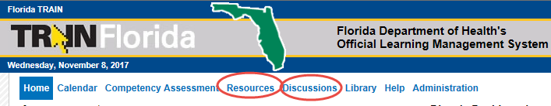
- We recommend you review the TRAIN Florida Announcements to keep up to date on changes to the TRAIN Florida site and courses.
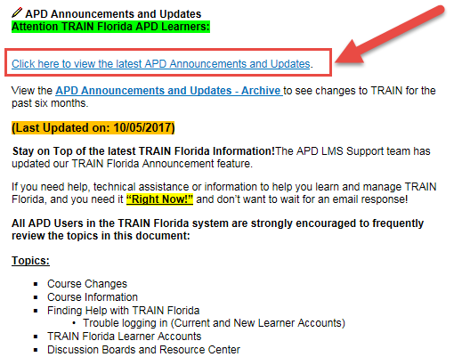
- If you continue to encounter problems after checking the resources listed above, please contact the TRAIN Florida APD site administrator by sending an email to apd.lmssupport@apdcares.org.

What is the difference between the TRAIN Florida Knowledge Center and the APD Training Portal?
The TRAIN Florida Knowledge Center is directed toward employees and learners who are taking Florida Department of Health (FDOH) courses. APD is a separate agency from FDOH and uses the TRAIN Florida LMS for some of its courses. This is why it is important for APD learners to go to the APD Training Portal for information about their primary information source.
Because APD is a separate agency from FDOH any issues APD learners have with their APD courses should not be addressed to FDOH. Learners addressing APD questions to FDOH support will not receive a response.

